Capstone Project Proposals

**TEAM-03 - COATL-AIRCRAFT**

**01/31/2025**

**Annika Boyd, Eisa Alsharifi, Felix Moss, Nathan Truong**

**REV #1**

# 1. Executive Summary

Atmospheric particles like volcanic ash, mineral dust, and wildfire smoke can cause significant damage to aircrafts. These particles can clog components, erode turbine blades, and lead to engine failures, as seen by the 1982 British Airways Flight 009 incident. Not to mention, long term exposure to atmospheric dust in regions such as the Middle East leads to a much more rapid degradation of aircraft components.

This project aims to design and develop an electrostatic dust analyzer (EDA) that detects when an aircraft flies through a particle cloud. To do this the EDA will use the natural electrostatic properties of atmospheric dust to measure particle flow and size using induced currents on a set of wire electrodes. The small, low-power device will be mounted on the underside of the aircraft and operate continuously, monitoring the surrounding air. This will provide vital information for pilots, so as to help them respond accordingly and the EDA could offer helpful information about atmospheric dust trends.

Over the next six months, the project will deliver a working prototype capable of detecting particles within the size range of 50–500 microns and electrostatic charges of at least 10 fC. The final product will include hardware for signal digitization and software for real-time data processing.

# 2. Background and Research

* **Sponsor**

Josh Méndez is a researcher working at the intersection of engineering, materials science, geophysics, and planetary science. His work focuses on triboelectric charging. His research spans laboratory and field experiments to understand frictional charging and its effects, from volcanic lightning to planet formation. He also applies electrostatics and wireless sensor networks to study hazardous granular flows like volcanic plumes and wildfire smoke. Additionally, Dr. Méndez explores the science of coffee brewing, addressing multiphase problems and developing tools to enhance the brewing process.

* **Technology Domain of Project**

The project develops an Electrostatic Dust Analyzer (EDA) to detect airborne particle hazards like volcanic ash, dust, and wildfire smoke, which can damage aircraft engines. Using electrostatic sensing, the EDA measures charged particles in real time by detecting induced currents on wire electrodes. Mounted like a pitot tube, it provides continuous in-flight data to enhance pilot awareness and safety. The system complements existing aviation monitoring tools and contributes to long-term atmospheric dust analysis.

* **How these Systems Work**

Electrostatic dust analyzers (EDAs) work by detecting the natural charge on airborne particles. As an aircraft moves through the atmosphere, charged dust, ash, or smoke particles enter the sensor, which consists of wire electrodes positioned at the inlet and outlet of a narrow tube. When these particles pass through, they induce small electric currents on the electrodes. The system measures these currents to determine particle presence, charge, and potentially size.

* **Previous Projects and Our Role**

This project applies electrostatic sensing to detect airborne dust hazards in aviation, adapting a similar PSU graduate student project that uses a picoammeter to detect raindrops. Instead of raindrops, our system focuses on charged dust particles like volcanic ash and wildfire smoke, which can damage aircraft engines. Using a miniaturized Faraday cup, the sensor captures particles, and a picoammeter measures the induced currents to determine their presence and size. Unlike weather radar, which cannot detect fine dust, this system provides real-time monitoring to enhance pilot awareness and safety. The next steps include refining the Faraday cup design, developing the detection circuit, and testing sensitivity to ensure reliable airborne dust detection.

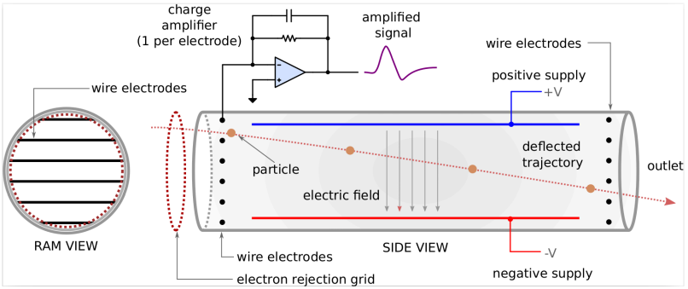

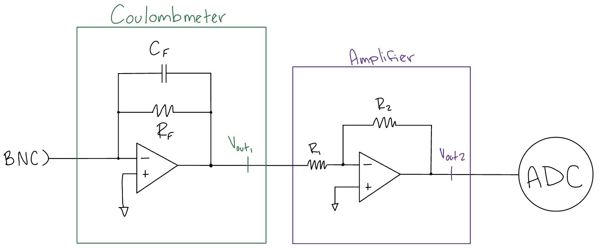

## Research

Currently, there is no commercial off-the-shelf project that can help with this project. The following articles were provided by our faculty advisor/sponsor:

* **Low Level Measurements Handbook - 7th Edition**

<https://download.tek.com/document/LowLevelHandbook_7Ed.pdf>

The first two chapters of the Low Level Measurements Handbook by Tektronix offer useful information for our electrostatic dust analyzer (EDA) project. Chapter 1 covers the challenges of measuring small signals and the importance of using the right equipment, like electrometers, coulombmeters, and picoammeters to measure very low voltages and currents. These instruments are essential for detecting the small charges created by airborne particles in our system. The chapter also emphasizes noise control, which will be crucial for maintaining measurement accuracy.

Chapter 2 focuses on the electrometer and ammeter. These tools are designed for precise low-level measurements, and the chapter provides us with the diagrams to build our own for measuring dust particles. Understanding how to use these tools effectively is key to ensuring our EDA can accurately detect charged particles in the atmosphere. Our EDA will need to be extremely sensitive to small charge variations caused by particles in the atmosphere, and the instruments and techniques discussed in these chapters guide our approach to achieving these measurements accurately. By understanding and applying the principles of noise reduction, precision measurement, and the correct use of instruments like electrometers, picoammeters, and SMUs, we ensure that the EDA provides reliable data for identifying particle hazards in the atmosphere.

* **Embedded Electrostatic Sensors for Mars Exploration Missions**

[Embedded electrostatic sensors for Mars exploration missions](https://www.sciencedirect.com/science/article/abs/pii/S0304388604000488)

This article on embedded electrostatic sensors for Mars exploration is highly relevant to our project because it focuses on utilizing sensor technology to capture and analyze environmental data. While the project is specifically about measuring electrostatic fields on the Martian surface, the core principles and methods used in the project can be applied to our design.

Like the Mars sensors, we are developing sensors that detect and measure specific physical properties within a given environment. The emphasis on integrating sensors into a rover’s wheels for continuous data collection while the vehicle moves can directly inform our own sensor placement strategy. In our project, we are also integrating sensors into our device or system that allows for continuous measurement without interrupting the overall system.

Additionally, the electrostatic sensor technology used in the project provides useful insights on how to measure changes in environmental conditions (like surface charge or frictional effects), which may influence how we would capture similar changes in current. The use of materials selected for their triboelectric properties also highlights how material choice can influence sensor performance. This is an extremely important consideration for our project as we select components for maximum accuracy and durability.

While the context of the Mars project is different, the sensor development and environmental data analysis techniques show us valuable ideas on integrating sensors into systems to continuously monitor and analyze data in real-time, which is directly applicable to our EDA.

* **Electrostatic Dust Analyzer for Dust Transport Measurements on the Lunar Surface**

<https://iopscience.iop.org/article/10.3847/PSJ/ad1ffe/pdf>

This EDA is relevant to our team as we develop our own because the principles of electrostatics outlined here are key to understanding how dust particles interact with electric fields. Our device will use these interactions to detect airborne particles, making these concepts essential for ensuring accurate measurements in the complex environment around an airplane.

Their EDA project also highlights the importance of precise calibration and design in electrostatic systems. For our dust analyzer, we need to ensure it can accurately detect different types of particles under various conditions, such as turbulence and changes in temperature. Their techniques of sensitivity adjustment and shielding/grounding that were discussed in their report will help us fine-tune our system to achieve the right sensitivity and detection range.

Finally, the project covers how to reduce interference and improve system reliability. Our dust analyzer will work with highly responsive equipment, so minimizing noise and ensuring clear data is critical. The methods and underlying concepts in this project help us design a more reliable and effective device for detecting particle clouds in the environment around airplanes.

* **NASA Patent for Mars Exploration Electrostatic Sensor**

<https://ntrs.nasa.gov/api/citations/20000058189/downloads/20000058189.pdf>

The MECA/Electrometer patent has significantly informed our design and testing process for developing the electrostatic dust analyzer (EDA) to detect particle clouds around airplanes. Their use of triboelectric sensors gives us a potential option of integrating similar sensor arrays into our system to measure the electrostatic properties of particles in the air. By using materials with varying triboelectric properties, we can see how different particles interact with the electrostatic field. This allows us to select appropriate materials for our sensors and fine-tune the EDA’s sensitivity for particle detection. Additionally, the patent's detailed description of the guard ring and electrode array design shows the importance of minimizing interference from leakage currents, ensuring the measurements are accurate in all conditions.

The patent’s solid-state switching mechanism also gave us insights into improving the calibration and automation of our analyzer. The use of low-leakage solid-state switches to zero the instrument, as opposed to mechanical switches, has shown us a potential way to make the calibration process more precise. This is especially important for our system, which needs to operate consistently and with extreme precision in adverse environmental conditions. Overall, the techniques and innovations outlined in the patent have provided us with a good understanding of electrostatic measurement, as well as potential solutions that are directly applicable to our system's design and testing phase.

# 3. Product Design Specification

## Product Overview

* **What is Our Product**
  + The electrostatic dust analyzer (EDA) detects and measures airborne particles, such as mineral dust, volcanic ash and wildfire smoke, that pose risks to airplane safety. It continuously monitors the particle environment around an aircraft during flight, providing real time data on particle characteristics.
* **How it Works**
  + The EDA consists of an open-ended tube with wire electrode arrays at the entrance and exit. Charged particles induce currents on these electrodes as they flow through the tube. The system processes these currents using analog and digital signal processing hardware to infer particle size and charge. This data is then transmitted to a serial USB connection for viewing by the user.
* **Potential Users**
  + Users of this technology include commercial airline pilots, flight crews, aviation regulators, aircraft manufacturers, and atmospheric scientists (i.e. our sponsor Josh Mendez).
* **Use Cases**
  + For airline pilots and manufacturers, this device will greatly enhance safety and maintenance costs. Not only will this prevent pilots from flying for too long in particle-dense areas, it keeps the aircraft from being damaged, allowing for less to be spent on maintenance. As for science, the aggregated data from flights about atmospheric conditions is useful for observing atmospheric dust content.
* **Project Delivery**
  + The initial prototype will be developed and tested in a lab environment first. After validation, our sponsor will take the developed product to Mexico for use in testing and analysis of atmospheric conditions.
* **How Users Utilize our Product**
  + Pilots will be able to view real-time data regarding hazardous conditions in the air and react accordingly. Maintenance teams will be able to look at long term data collections that provide insight on when to schedule repairs or replacements. Scientists can view data logs from multiple flights and compare that new data with older information for further analysis.
  + In order to use the EDA, a compatible interface for storing the data coming from the EDA’s outputs is needed, as well as a power supply for the entire device.
* **Product Life Cycle and Timeline**
  + **Lifecycle** 
    - The product should last around 10 years or so. Project development will last 6 months and be finished in July. Once completed, the device should be operational for approximately 10 years with periodic maintenance.
  + **Timeline**
    - **3 Months:** 
      * Development of circuit and physical design. Begin prototyping and testing.
    - **6 Months:** 
      * Product is fully functional after testing, validation, and refinement. Deliver to sponsor for use in experimentation.
    - **1 Year:** 
      * Product is used in experimentation at sponsor’s discretion
    - **2 Years+:** 
      * Product is subject to testing and regulatory approval. Device potentially becomes available for integration into aircraft fleets as a standard tool for aviation safety and atmospheric research.

## Stakeholders

* **Team 3 Members**
* **Josh Méndez,**
* **COffee And Telesensing Lab at Portland State University**

## Requirements

* **Must**
  + Device is able to detect particles
  + Device is sensitive to electrostatic charge
* **Should**
  + Low consumption of power
  + Small in size
  + Able to determine the size of particle

## Initial product design

* **Hardware architecture**
  + **L0 and L1**

**L0 Block Diagram**

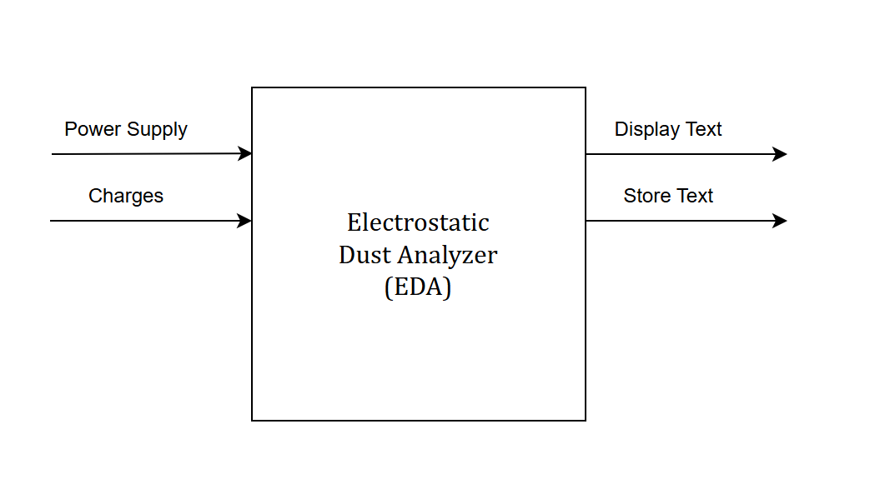

**L1 Block Diagram**

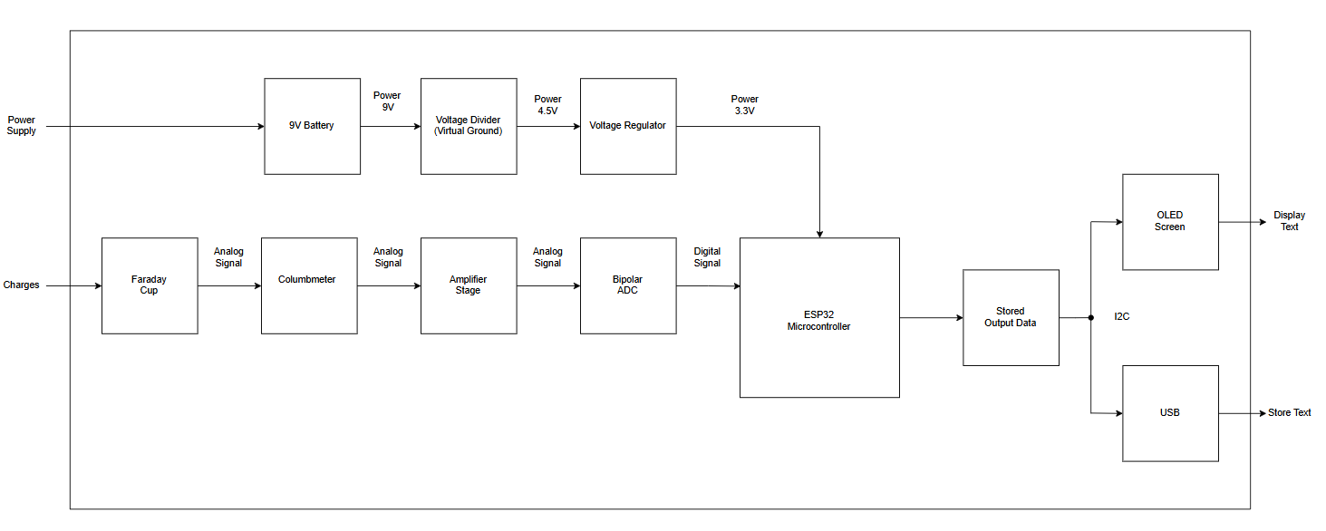

* **Software Architecture**
  + **Programming Languages:**
    - C/C++: Used for programming the microcontroller to control hardware components (e.g., ADC, amplifier, sensors) and implement data processing algorithms.Development Environments:
    - Arduino IDE: Popular for programming ESP32 due to simplicity and extensive library support, ideal for rapid development and testing
    - Git: To track version control and manage team contributions, and an easy way to share software files
* **Data Flow in the Software**
  + **Data Collection:**
    - The microcontroller receives digitized signals from the ADC, which represent the particle charges and sizes detected by the electrodes.
  + **Data Processing:**
    - Noise filtering through digital signal processing (DSP).
    - Converts ADC data to meaningful measurements, such as particle charge and size.
  + **Decision Making:**
    - The microcontroller evaluates the processed data to determine if a hazardous particle cloud is present. This may include checking thresholds for charge density or particle size.
  + **Data Transmission:**
    - The microcontroller sends results to the pilot interface using serial communication (USB or UART) for real time feedback or logging.
* **User Interface / Experience**
  + **Pilot Experience:**
    - Pilots receive real-time alerts on the cockpit’s OLED display about airborne particle concentration, allowing for immediate course adjustment to avoid hazardous zones, enhancing in-flight safety.
  + **Research and Development Experience:**
    - Researchers access detailed particulate data via USB for analysis facilitating ongoing improvement in predictive maintenance and environmental impact assessments.
* **Other Considerations**
  + **Security**
    - **Physical Security:**
      * The device will be mounted on the aircraft to keep it stable under flight conditions (such as turbulence, temperature changes, etc).
      * It will have a housing that will protect the electronics from moisture, dust, water, etc.
    - **Electronic Security:**
      * Shielding and grounding will be added to prevent electromagnetic interference (EMI) that could affect our EDA.
      * Insulation will be used to avoid short circuits and protect sensitive components from power surges.
    - **Software Security:**
      * Encryption for data transmitted over Wi-Fi or Bluetooth may be added if needed.
      * Maybe include password protection or some such to limit configuration changes to only those that need it.
  + **Regulatory Compliance**
    - **Aviation Standards:**
      * The EDA must comply with FAA and EASA regulations for airborne electronic equipment, including standards for electromagnetic compatibility (EMC) and safety.
      * The EDA’s design will consider DO-160 standards for environmental testing of airborne equipment, such as vibration, temperature, and pressure.
  + **Radio Frequency Compliance:**
    - If the device uses wireless communication (Wi-Fi or Bluetooth), it must comply with FCC standards for the US and NOM-208-SCFI-2016 standards for Mexico to make sure we have legal operation and certification in both areas.
    - The design will follow frequency band and output power limits to avoid interfering with other avionics systems.

## Verification plans

To make sure our system meets the project requirements and performs as expected, we will use the following testing strategy:

* **Functional Testing**
  + Test the ability of the electrodes to detect charged particles by introducing controlled particles with known sizes and charges (using shaken sand or volcanic ash).
  + Verify the coulomb meter accurately measures the charge induced by the particles (possibly a way to compare the charges with equipment in the lab).
* **Signal Amplification and Conversion**
  + Validate that the amplifier properly boosts the signal from the coulomb meter without significant distortion.
  + Confirm that the ADC correctly digitizes the amplified signals for the microcontroller.
* **Data Processing and Transmission**
  + Make sure the microcontroller processes the digitized data accurately and identifies the particle size/charge based on input signals.
  + Test the transmission of processed data to the pilot interface, hopefully under simulated flight conditions.
* **System Integration Testing**
  + Simulate particle clouds to test the full system, data flowing from the electrodes to the pilot interface.
  + Confirm that a sudden rise in particle counts triggers an alert or appropriate feedback for the pilot or at least displays correctly.
* **Pass/Fail Criteria**
  + The system must detect particles with diameters in the 50–500 micron range with charges of at least 10 fC.
  + The system should operate continuously without interruption during the test.
  + The output data must line up with known test particle parameters within an acceptable margin of error (maybe ±5% for size, ±10% for charge).
  + The pilot interface must receive data updates in real-time (or almost real time) without major delays.
* **Documentation and Reporting**
  + Record all test results systematically, including raw data, processed results, and any unexpected outcomes.
  + Provide proof of compliance with "must" requirements and note any areas for improvement before handoff to the industry sponsor.

## Risks

* **Technical Risks**
  + **Electrode Sensitivity:**
    - The electrodes may not detect particles with the required precision or sensitivity (50–500 microns and charges ≥10 fC).
      * Possible Solution: Have early experiments with controlled particle environments to check and deal with electrode sensitivity.
  + **Signal Noise:**
    - The amplified signal may include too much noise to accurately read our data.
      * Possible Solution: Using proper shielding and filtering to minimize noise in the circuit.
* **Existential Risks**
  + **Time Constraints:**
    - The project timeline may not allow enough iterations or testing to fully fix all issues with the system.
      * Possible Solution: Prioritize the main required functionality (particle detection and data transmission) and deal with secondary features later if necessary.
  + **Budget Limitations:**
    - The cost of components or unexpected expenses may exceed the budget.
      * Possible Solution: Select cost-effective components and think about trade-offs between performance and budget.
  + **Communication Issues:**
    - Data transmission to the pilot interface might not function correctly due to software bugs or hardware malfunctions.
      * Possible Solution: Test communication multiple times under simulated conditions.
* **Critical Questions**
  + How accurately can the system differentiate between particle sizes and charges?
  + Can the system process and transmit data quickly enough for real-time feedback?
  + Will the design function consistently in different environmental conditions, such as turbulence or extreme temperatures?
  + What calibration processes are required to ensure consistent performance, and how frequently must calibration be performed
* **Unanswered Questions**
  + The long term durability of the electrodes under continuous use is unknown due to limited testing time.
  + We might not fully verify how accurately the system handles unknown environmental particles.
* **Back Up Plans**
  + **If Particle Detection Fails:**
    - Simplify the system to detect only the presence or absence of charged particles without detailed size/charge analysis.
  + **If Data Transmission Fails:** 
    - Store data locally on the microcontroller and provide pilots with a post-flight analysis instead of real-time feedback.
  + **If Project Timeline Falls Short:** 
    - Deliver a partial system that demonstrates proof of concept for particle detection and signal processing, even if full integration is incomplete.
* **Fallback Deliverable**
  + At a minimum, the team will deliver a working prototype capable of detecting charged particles and outputting data for further analysis, even if full functionality (such as real time alerts) is not achieved.

## Deliverables

* **Documentation**
  + Project proposal
  + Weekly Progress Reports
  + Final report
  + Test plans
  + User Manual
* **Hardware**
  + A device capable of detecting particles with diameters in the range of 50-500 µm (must)
  + Detect charges of at least 10 fC (must)
  + Digitize the analog signals (should)
  + A software to measure the particle size (should)
* **Software**
  + Using a microcontroller, the software and firmware is published on Git to properly operate and re-design the EDA using Git
  + A way to send all the data acquired to another device or server
* **Presentation**
  + Weekly or bi-weekly meetings with the sponsor
  + ECE Capstone Poster Session poster
* **Delivery Method**
  + Digital content: all digital files, including software, documentation, CAD design, and 3D print design to the team’s dedicated Git repository
  + Physical contents: all functioning prototypes and the final working product will be delivered to the sponsor

# 4. Project Management Plan

## Timeline, with milestones

* **Gantt Chart**
  + [Team 3 Gantt Chart](https://docs.google.com/spreadsheets/d/1_7xgBOEVhSrhBdYwNqpK6ZXGdGlyBkKYaVhsfQWFYbA/edit?usp=sharing)
* **Timeline Milestones**
  + **End of Week 3:**
    - Research phase completed, project proposal submitted.
  + **End of Week 6:**
    - Initial design finalized.
  + **End of Week 10:**
    - First working prototype ready.
  + **End of Week 14:**
    - Testing phase completed with feedback.
  + **End of Week 17:**
    - Second prototype refined and verified.
  + **End of Week 20:**
    - Final project delivered.

## Budget and Resources

Our team’s budget is approximately $1000. The allocated budget will cover circuit parts, PCBs machining materials, and potentially 3D print plastics during the design, prototyping, testing, and refinement phases of development.

For workspace, we will be using both the Capstone Lab and the MME Manufacturing Lab along with room 085-03 as the main meeting hub. Additionally, we may use the EPL as a resource for 3D printing or acquiring circuit parts.

## Intellectual Property Discussion

The IP for this project is in the public domain. The design, implementation, and results of this project are freely available for public use, distribution, modification, and reproduction without requiring permission or payment.

## Team

* **Felix Moss:**
  + Strengths: Schematic and PCB design, group documentation/management, soldering.
  + Areas of Practice: 3D printing, machining, analog-to-digital circuitry, op-amps.
  + Role: Group documenting, physical designing, validation
* **Eisa Alsharifi:**
  + Strengths: Schematic, PCB layouts, C programming, soldering, BOM/ tracking expenditure
  + Areas of Practice: 3D design, op-amps, analog-to-digital conversion.
  + Role: Circuit designing, validation, BOM/ordering
* **Annika Boyd:**
  + Strengths: Schematic design, soldering, hardware debugging.
  + Areas of Practice: 3D design, machining, analog design.
  + Role: Circuit design, validation
* **Nathan Truong:**
  + Strengths: Circuit design, prototyping, hardware debugging, data analysis.
  + Areas of Practice: Analog design, op-amps, 3D design.
  + Role: Physical designing, validation

## Development Tools and Process

* Our team is splitting the work up into six phases: Planning, Design, Prototyping, Testing, Refinement, and Finalizing. Time during each phase will be dedicated explicitly to completing the goals outlined in the Gantt chart.
* For collaboration, we are using Discord, Git, Google Drive, and Email.
* For technical tools, we will be using KiCAD, LTSpice, Arduino IDE in C, and Fusion 360.

## Acceptance and Sign-Off

This section serves to confirm that the undersigned faculty advisor and industry sponsor have reviewed the content of this project proposal and agree with the plan laid out herein for the Capstone Project, COATL-AIRCRAFT. The undersigned acknowledge that the proposal meets the necessary criteria and that they support the project’s objectives, methodology, and timeline as documented.

This acceptance also verifies that the faculty advisor and industry sponsor commit to providing the necessary oversight, support, and resources to ensure the project’s successful completion as envisioned.

**Faculty Advisor & Industry Sponsor:**

**Name: Joshua Mendez**

**Signature: **

**Date: 1-Feb-2025**